**Documentation for AlmaBridge**:-

AlmaBridge is a collaboration website where alumni can interact with existing students to share their experience and knowledge.

**Step by step working procedure of AlmaBridge** :-

1. When any user visits the AlmaBridge , the home page looks like this-

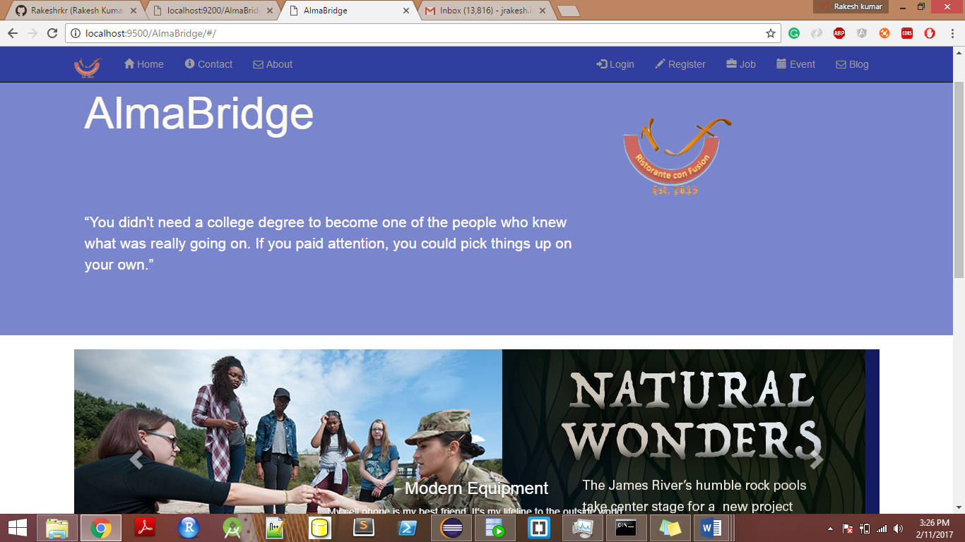

On the navbar few buttons are added:-

* Home , Contact us , About us , login , register , event , job and blog .

Below navbar, Header is listed which contain Logo and a quote.

Below Header, Carousel is situated which contains 4 sliding college pictures.

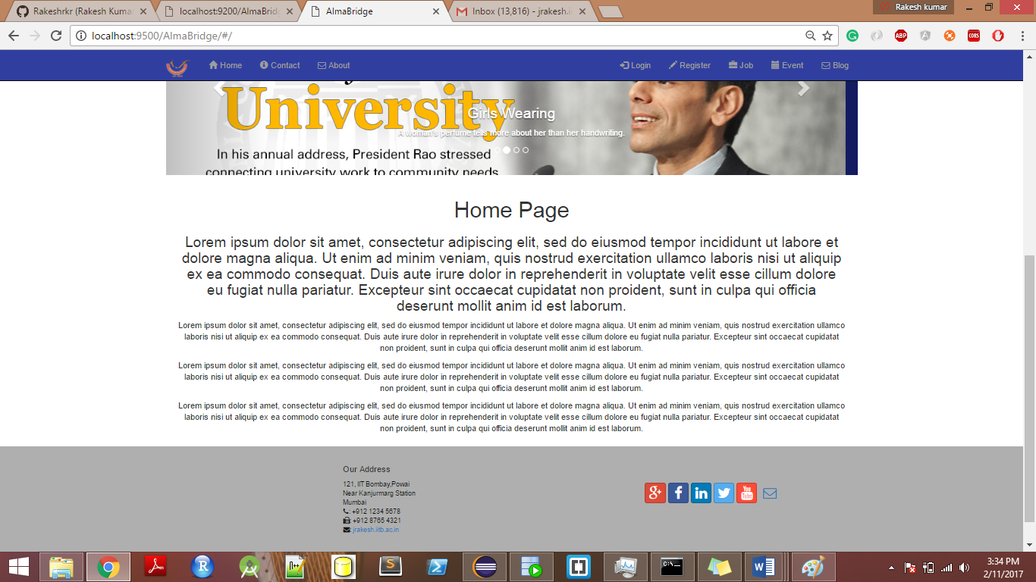

Below carousel, Some quotes followed by footer are listed, which contain links for social sites and contact information.

1. If user clicks on Contact us button, it navigates to contact us page.

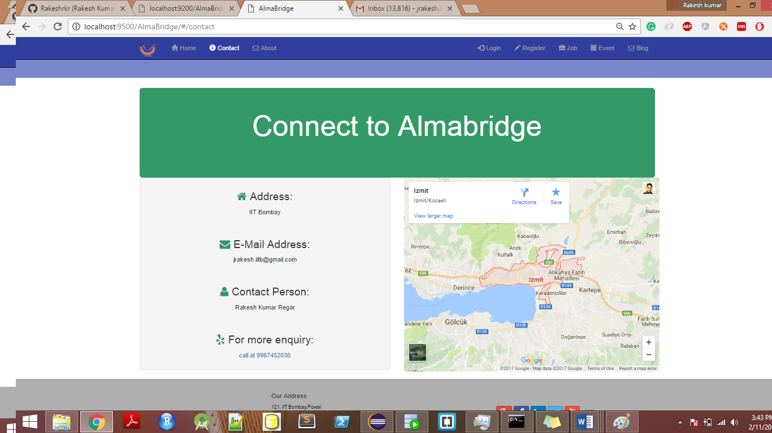

This contact us page contain some information like email address, contact person and google map of the location.

1. If user clicks on about us button, it navigates to about us page.

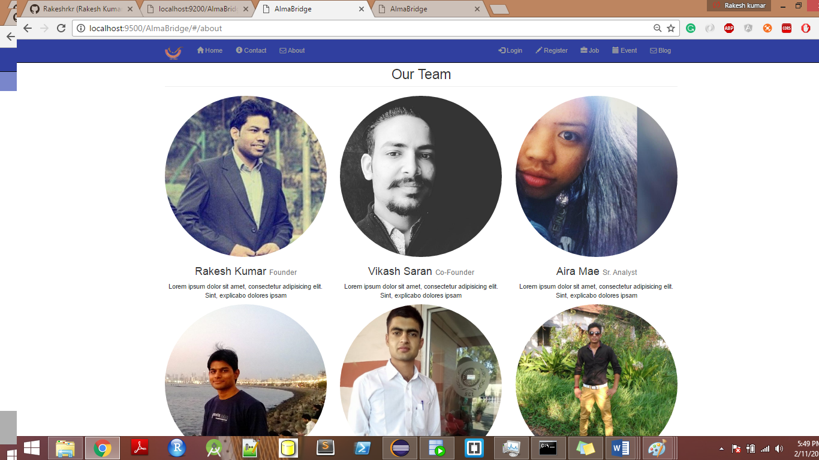

1. Now let’s consider two users Bob and Alex. Bob is a student and Alex is Alumni.

Bob wants to register as student on the website so clicks on Register button and fill the data. Name (only string), Mobile No. (only 10 digits), gmail (valid email pattern), username and password are key fields.

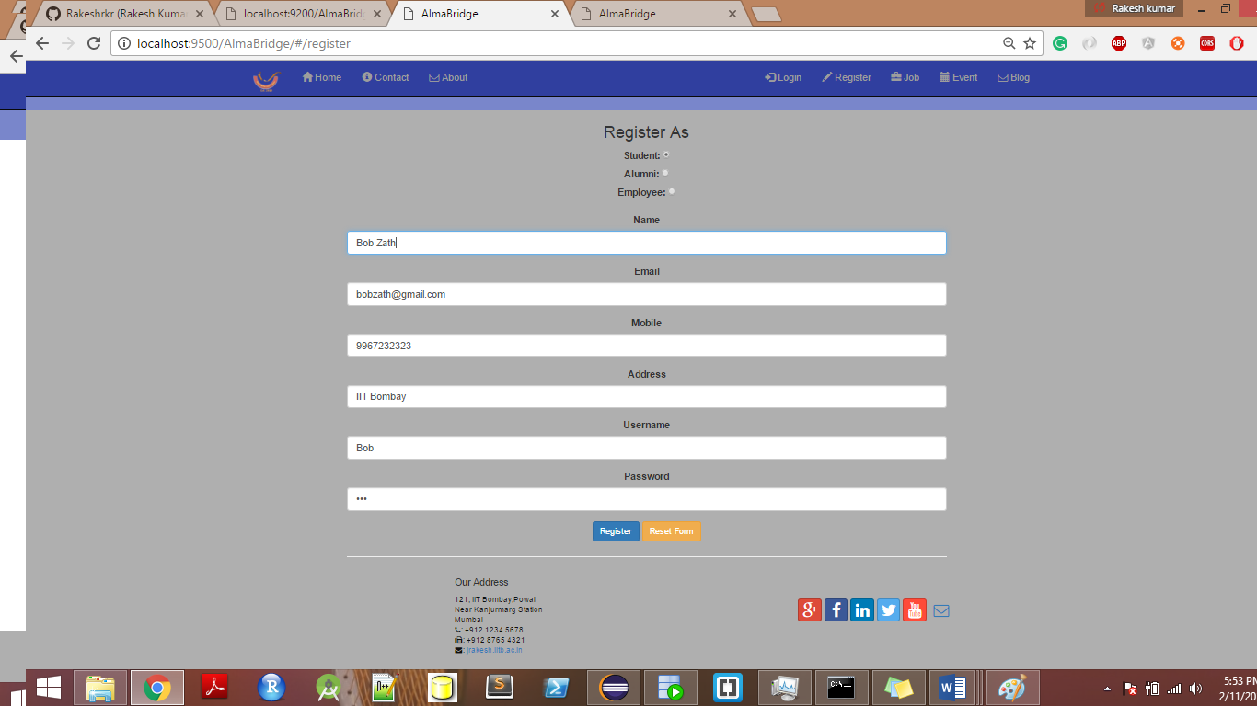

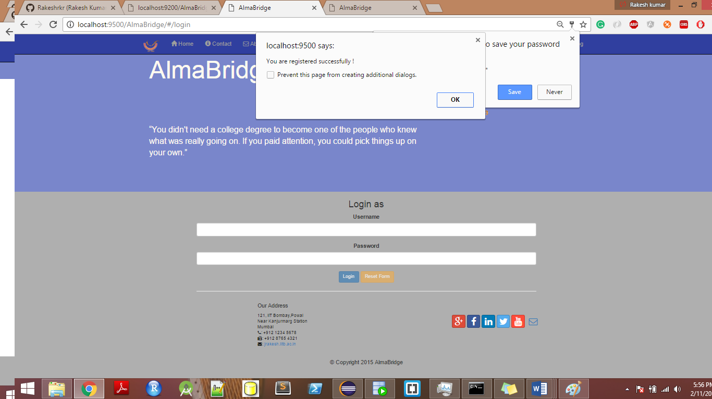

As Bob clicks on register, a notification is sent on screen saying you are registered successfully.

Same like this, Alex also registers as Alumni.

Now admin (Rakesh Kumar) have to accept or reject these guys based on correct information provided by them.

After admin logged in users page look like this.

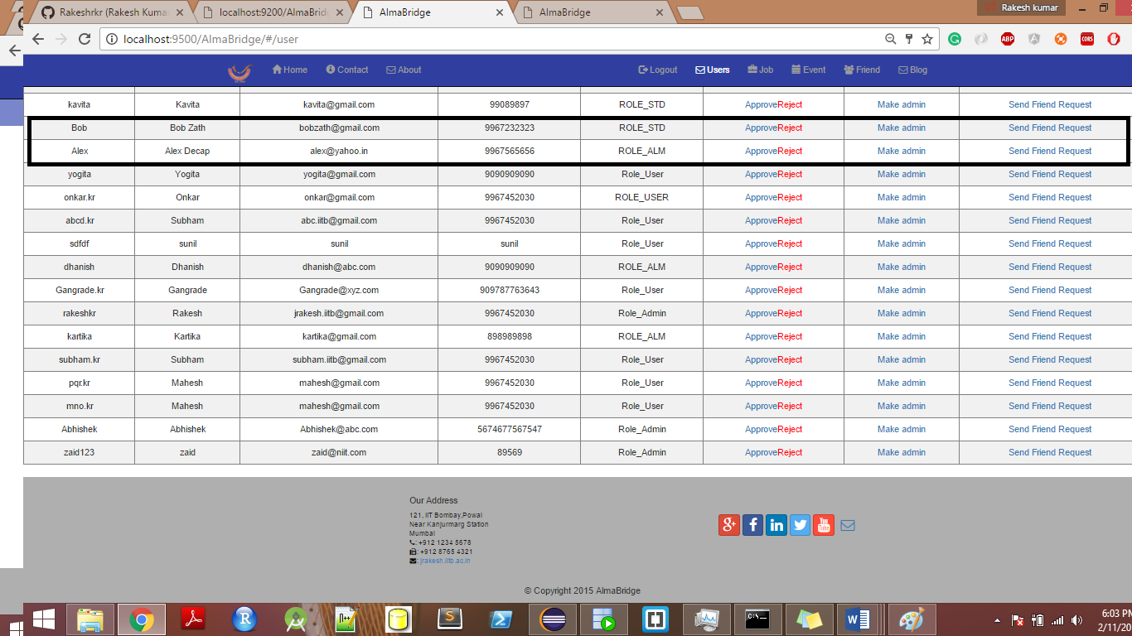

Now admin can accept/reject the registration request based on the information. Suppose admin approves both so clicks on accept button. Admin can also make them junior admin if he wants.

After approving , Bob and Alex are now able to login on website.

1. Now Bob login using his password and username.

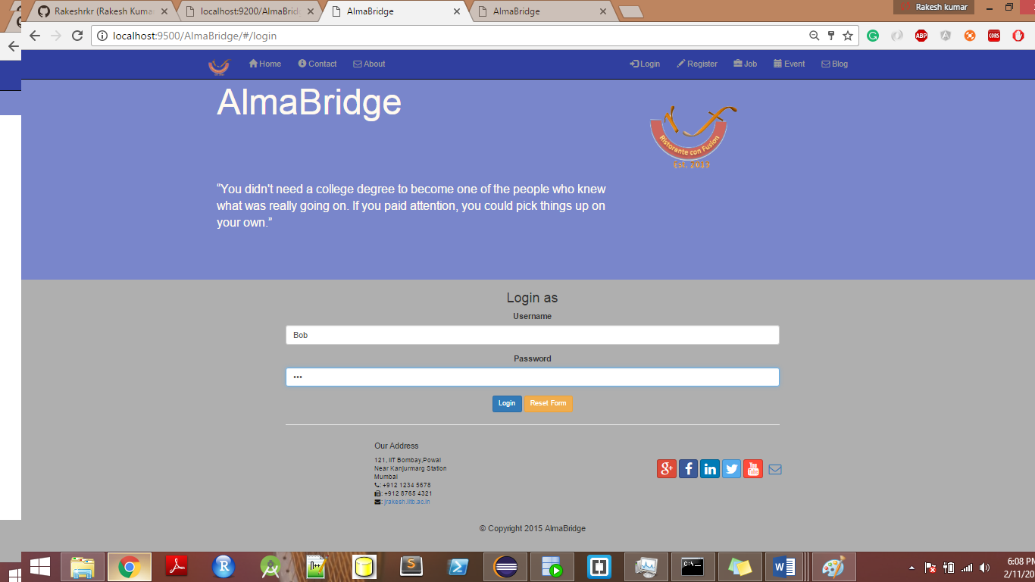

Now Bob can view users, send them friend requests , post blogs , post events and post jobs.

Note :- Admin can also do the same but admin have some more access to delete event and jobs.

1. Bob’s user page look like this.

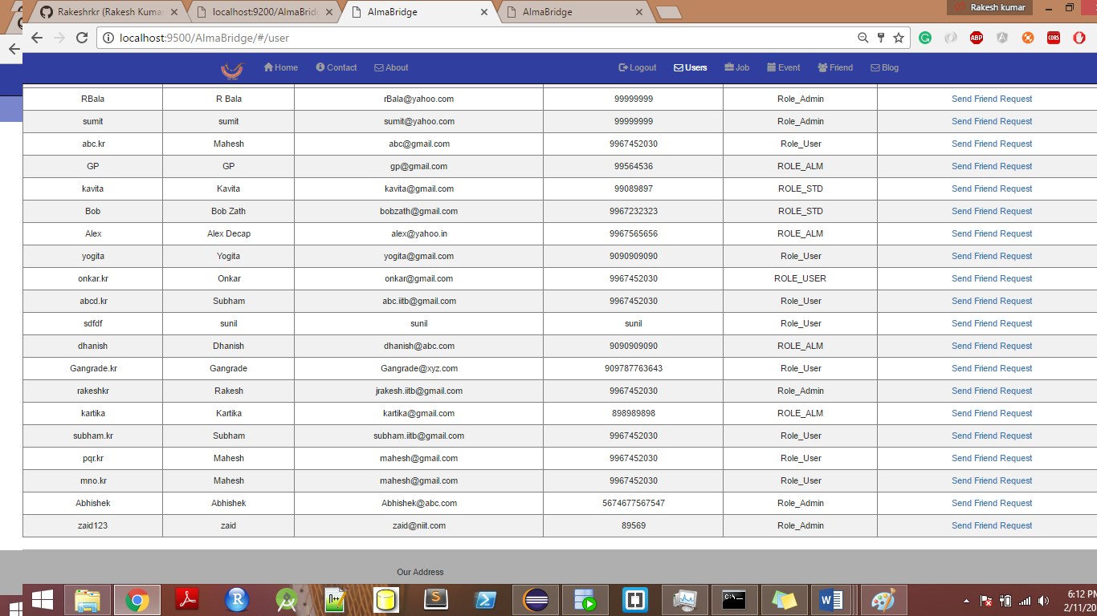

And job page

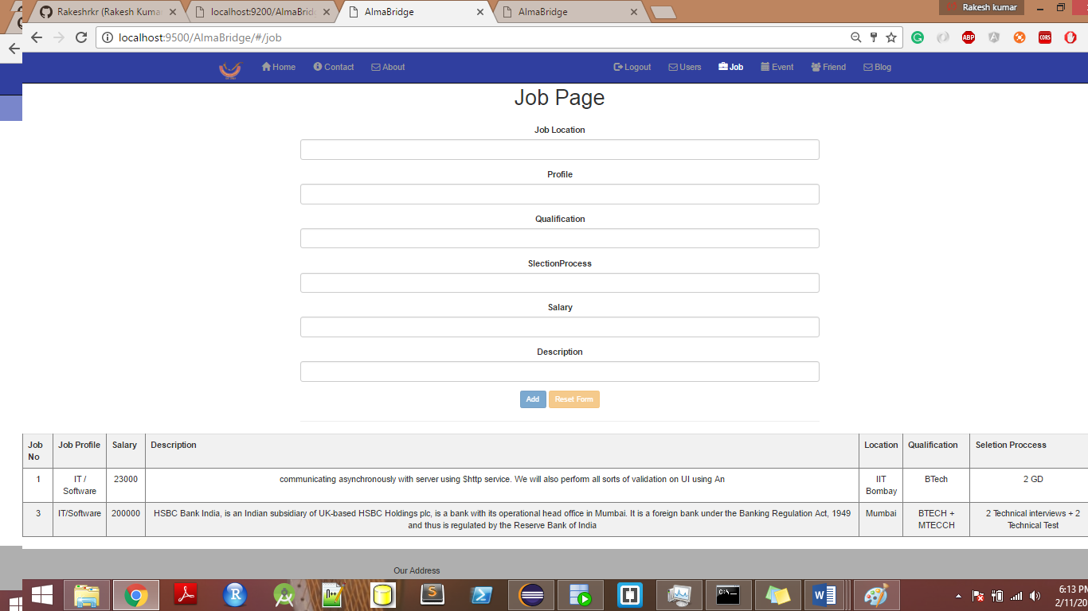

And Event page 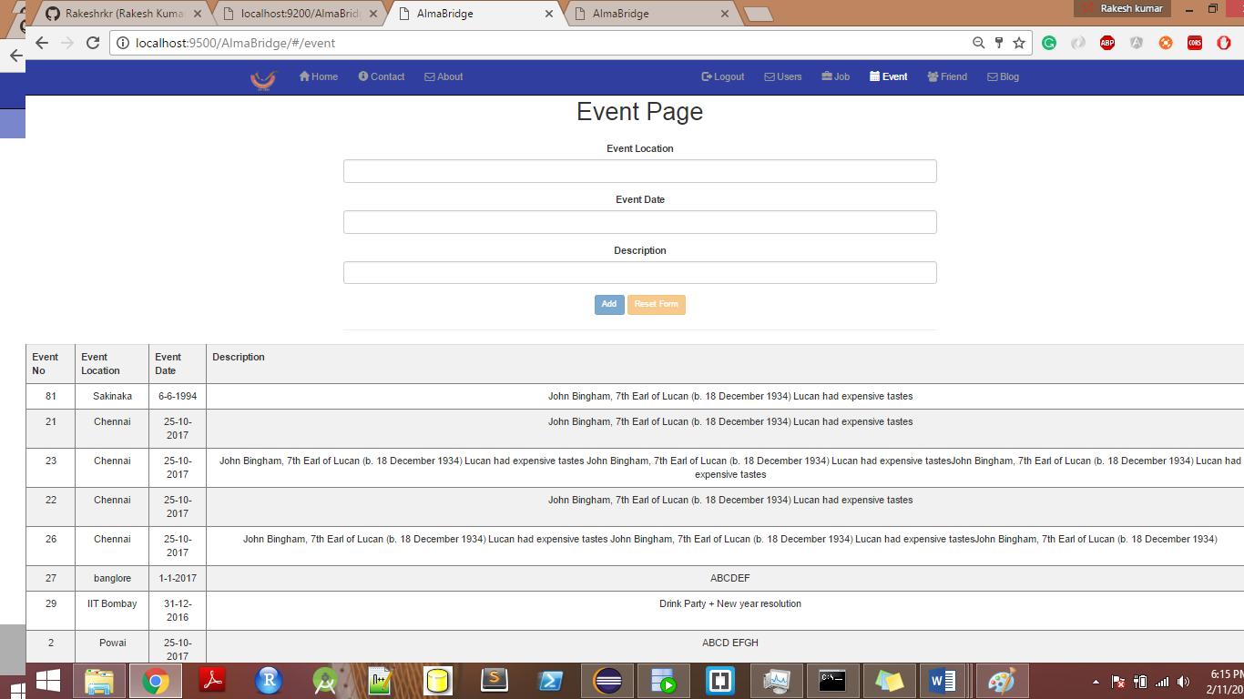

And Blog page

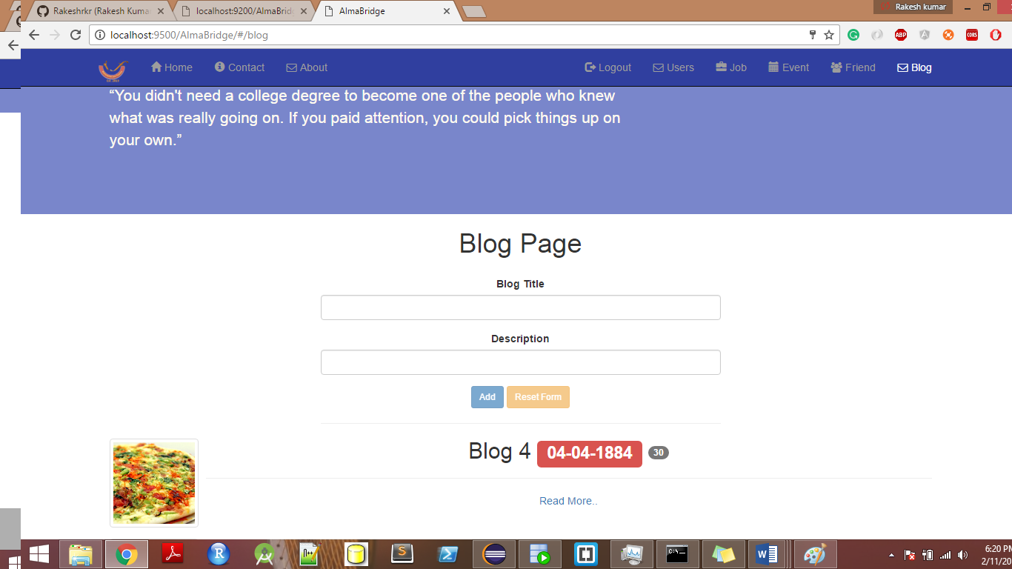

If Bob clicks on Read more , it navigates to different page.

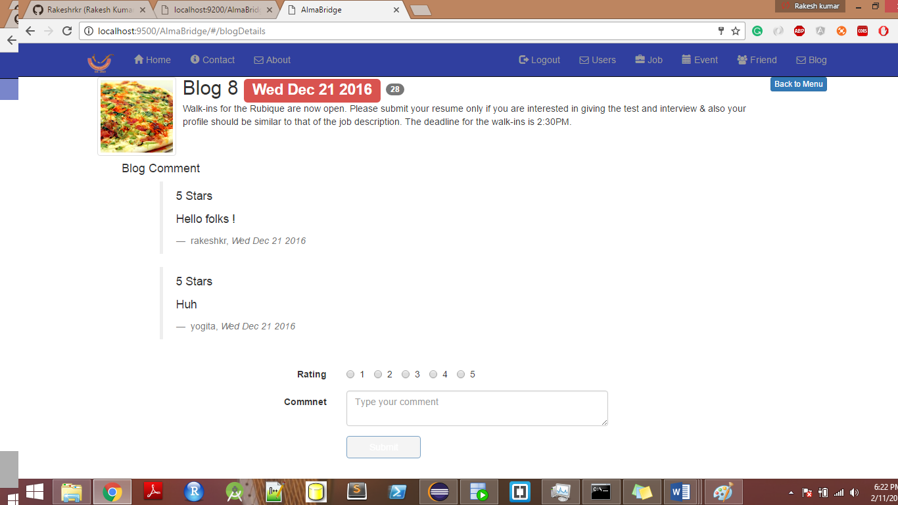

Now Bob can comment on the blog too.

1. Now suppose admin logs in and create blogs, events and jobs.

**Creating blog and commenting on it:-**

Admin creates a blog title – Documentation, with some description.

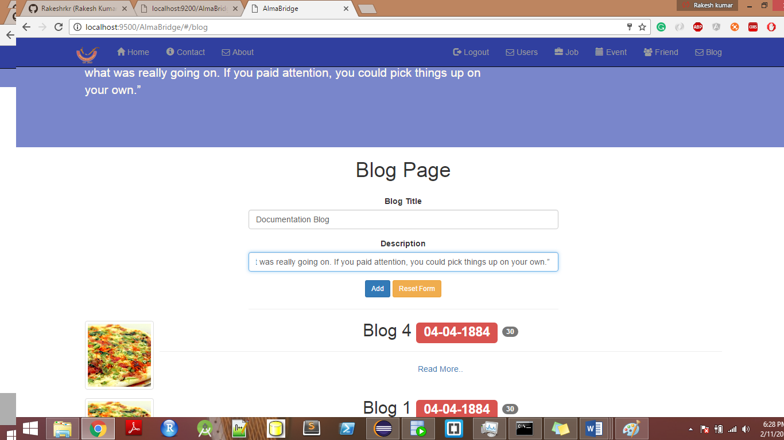

As he clicks on add button new blog is created with current date.

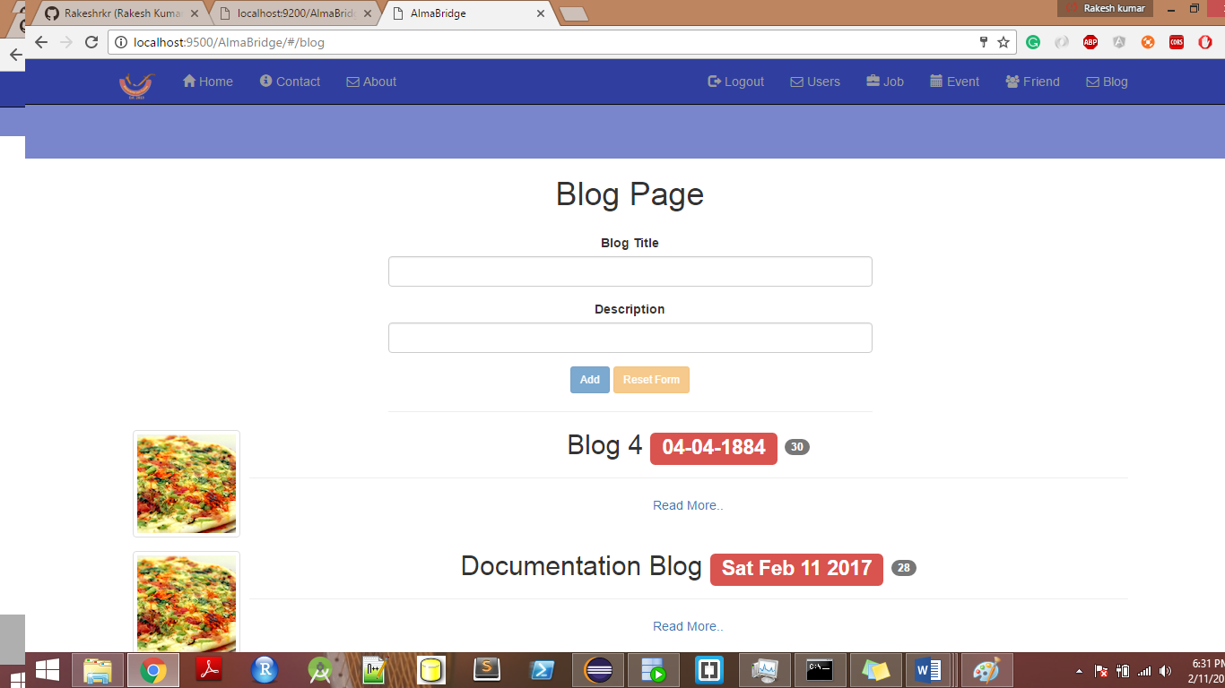

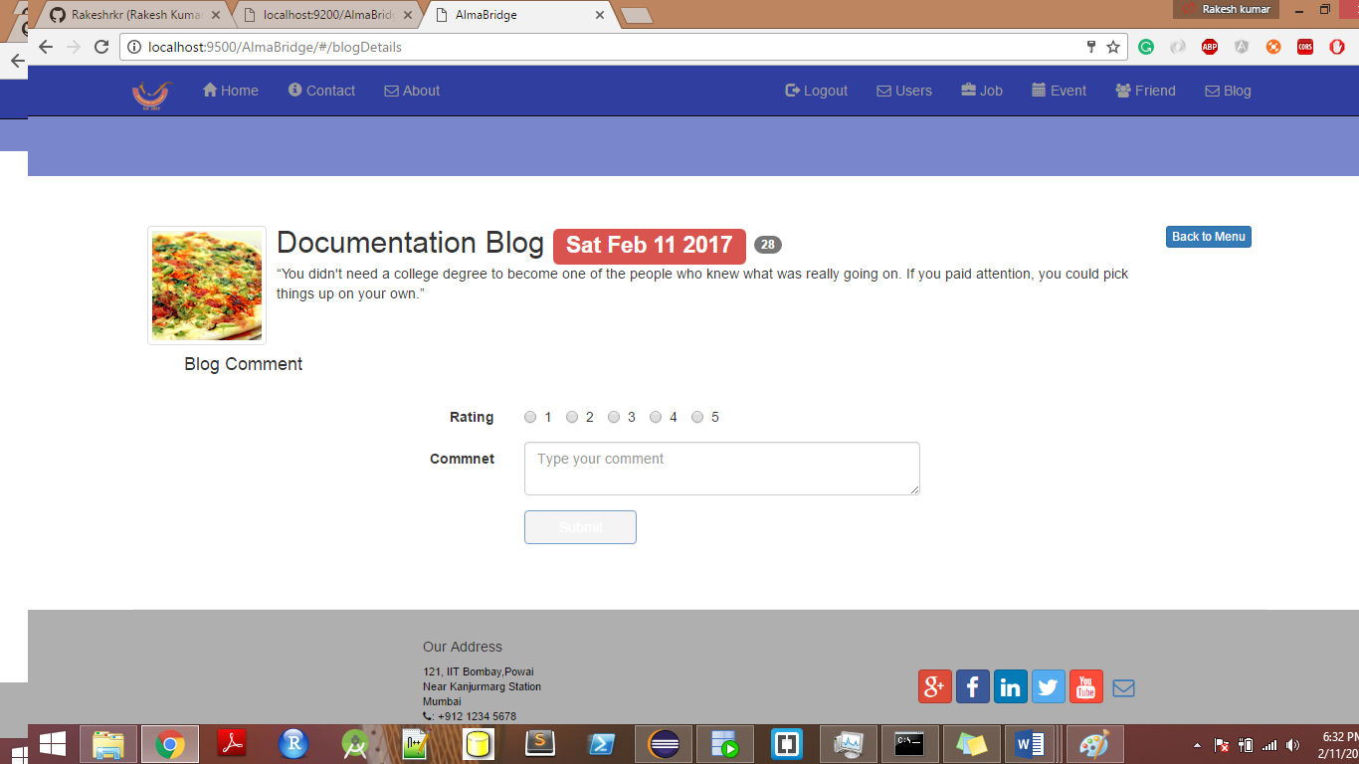

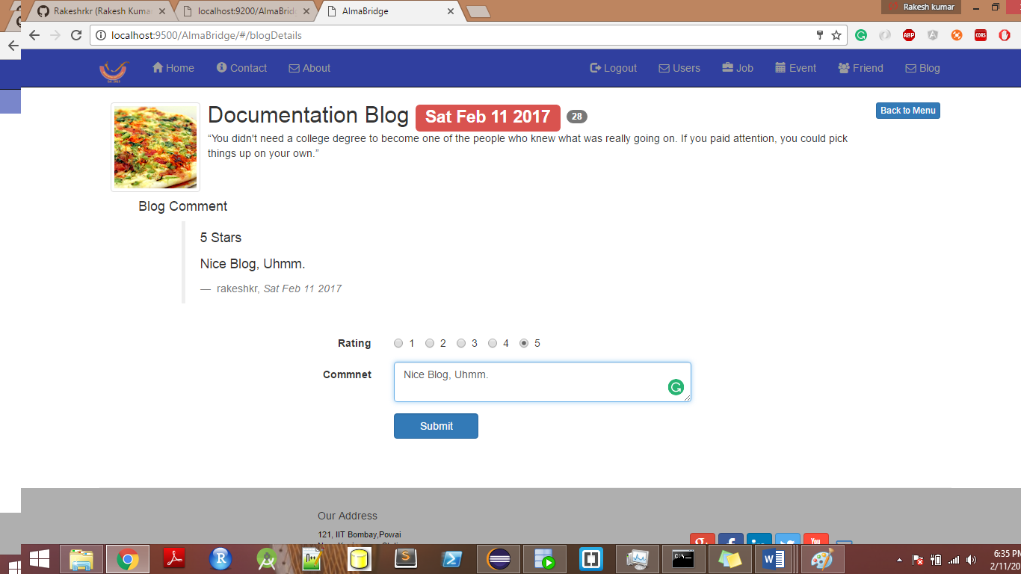

Logged In user can comment too. After comment on blog , the blog comment form reset to empty.

**Posting job description**

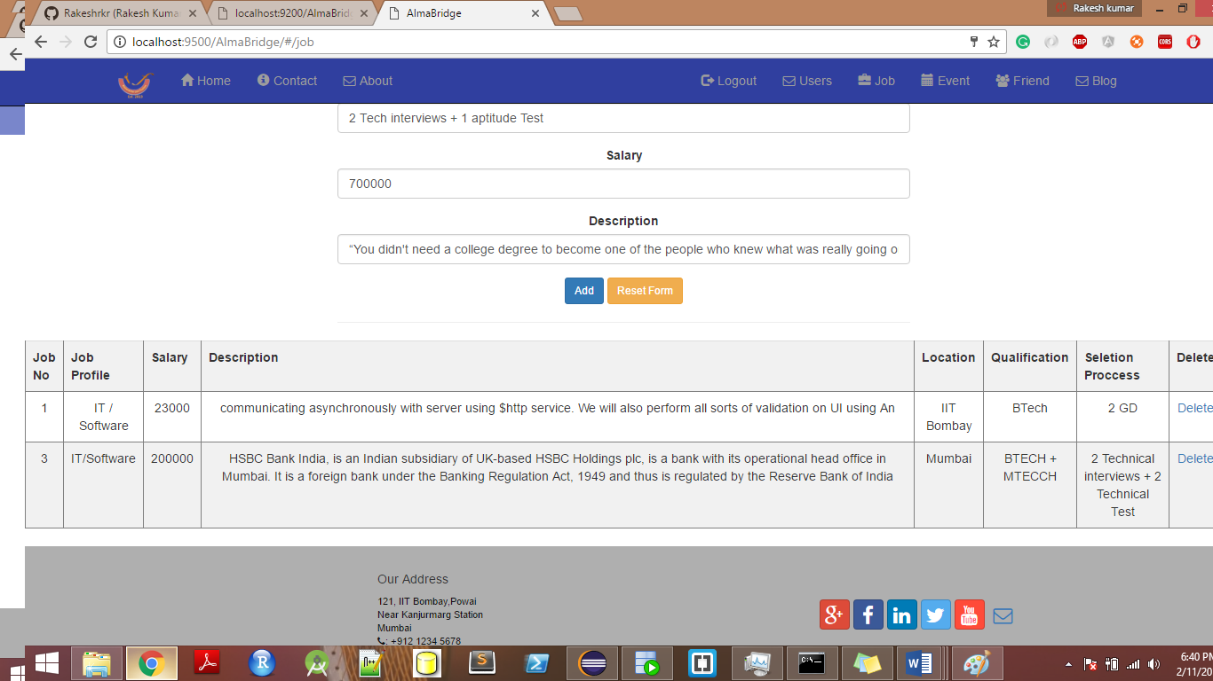

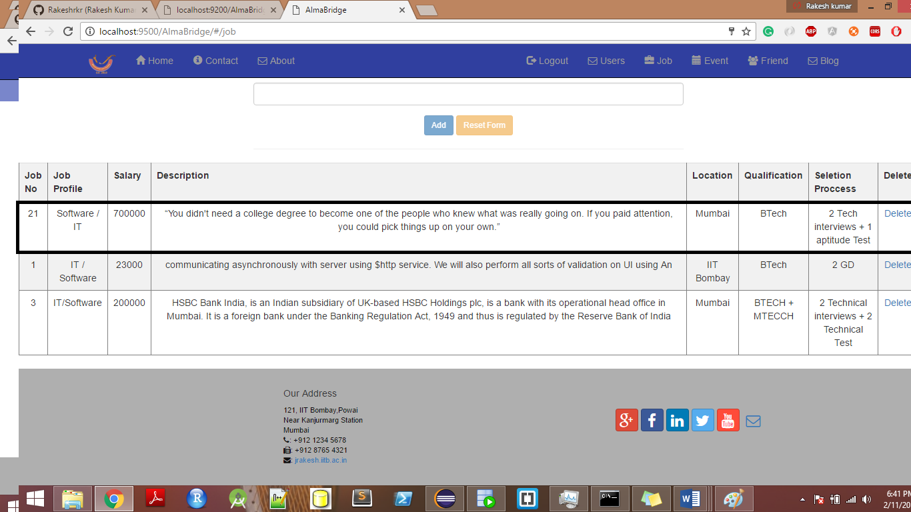

**Posting Events:-**

As shown above, a logged in user can post event , but only admin have authorization to delete the event.

1. Now let’s make Bob and Alex friends and do some chatting fun.

Bob send friend request to Alex.

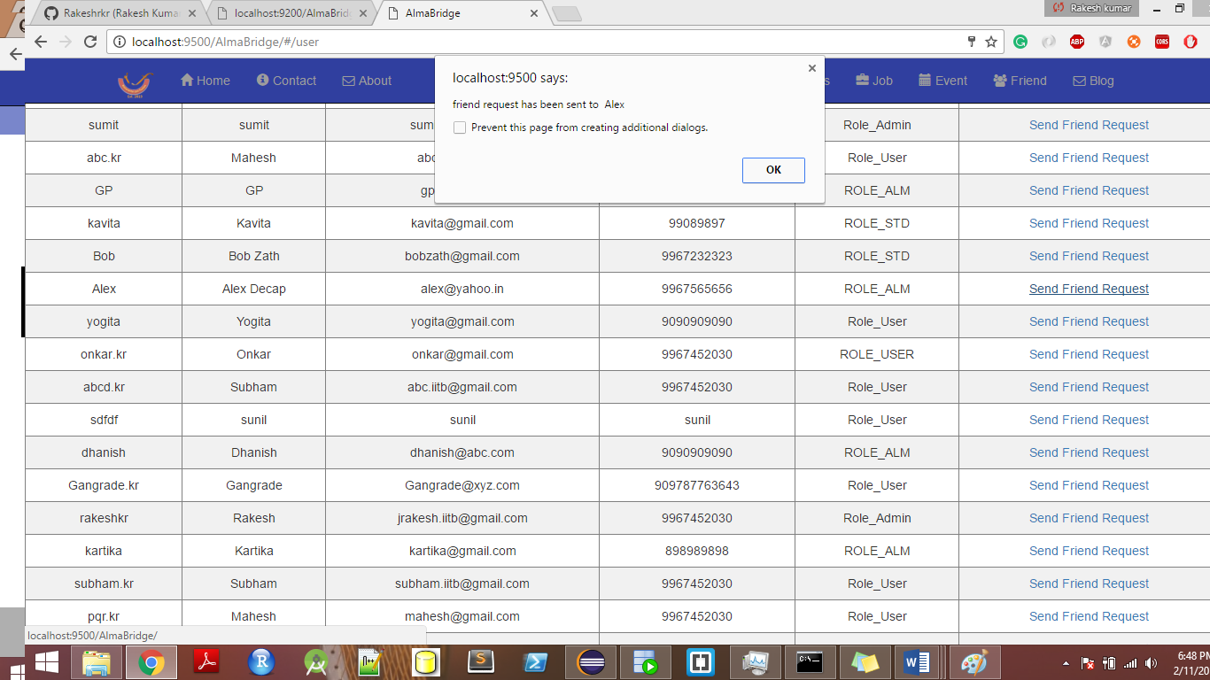

Friend list of Alex looks something like this :-

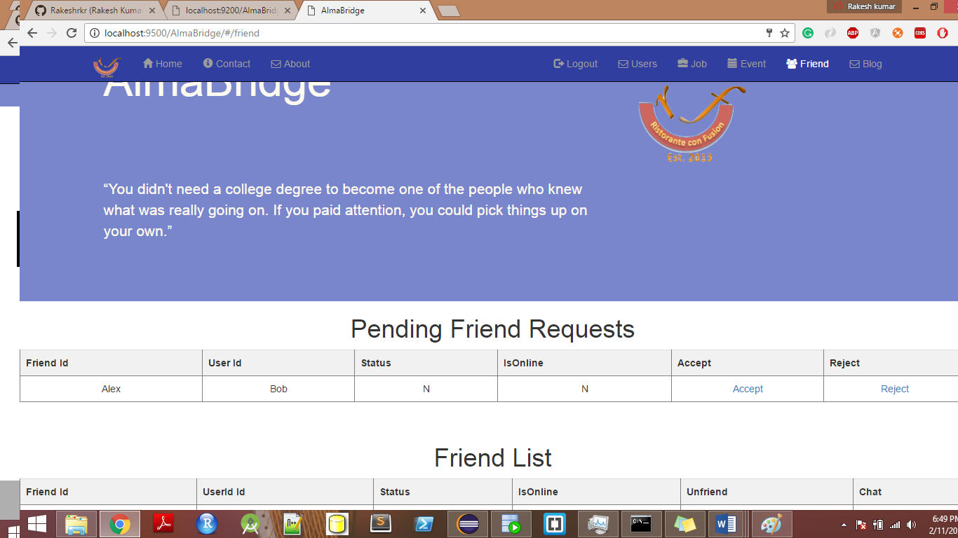

Alex can accept or reject the request. But Alex know Bob very well and accepts his friend request.

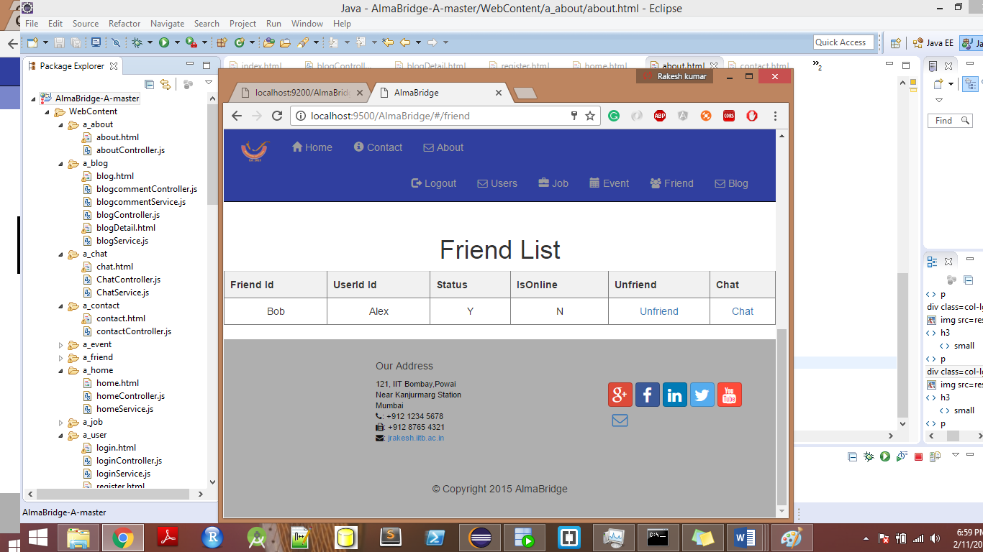

Alex still can unfriend bob if he wants but they are close frineds. Alex won’t do this.

1. **Chatting**

For chatting , we have to use two different tabs.

On the left side Alex is logged in and Right side Bob.

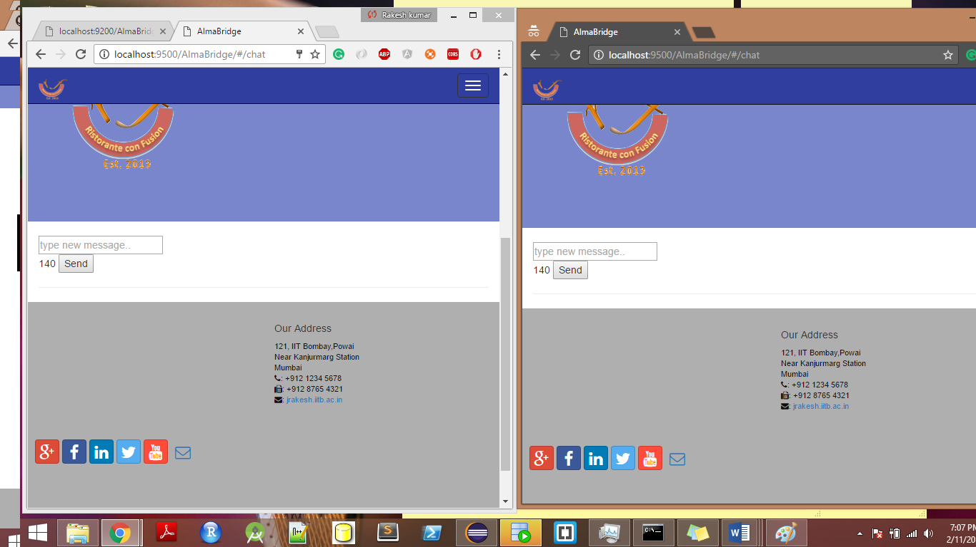

Some chatting screen shots are attached here.

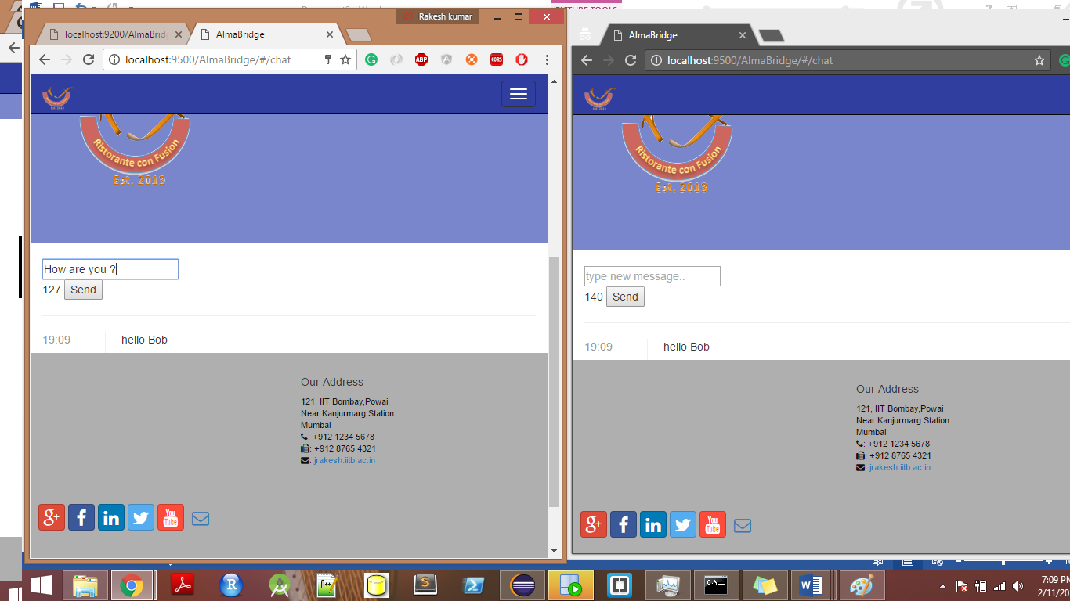

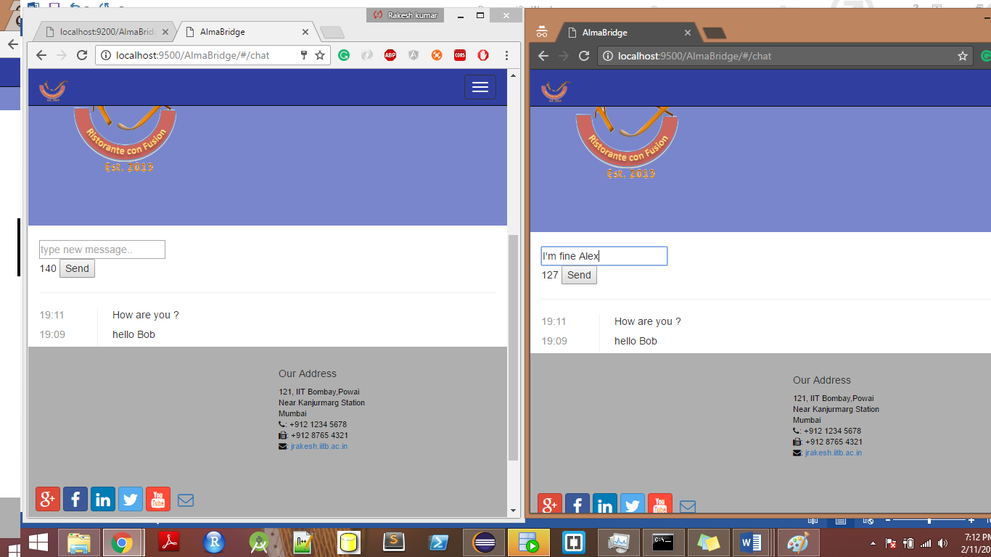

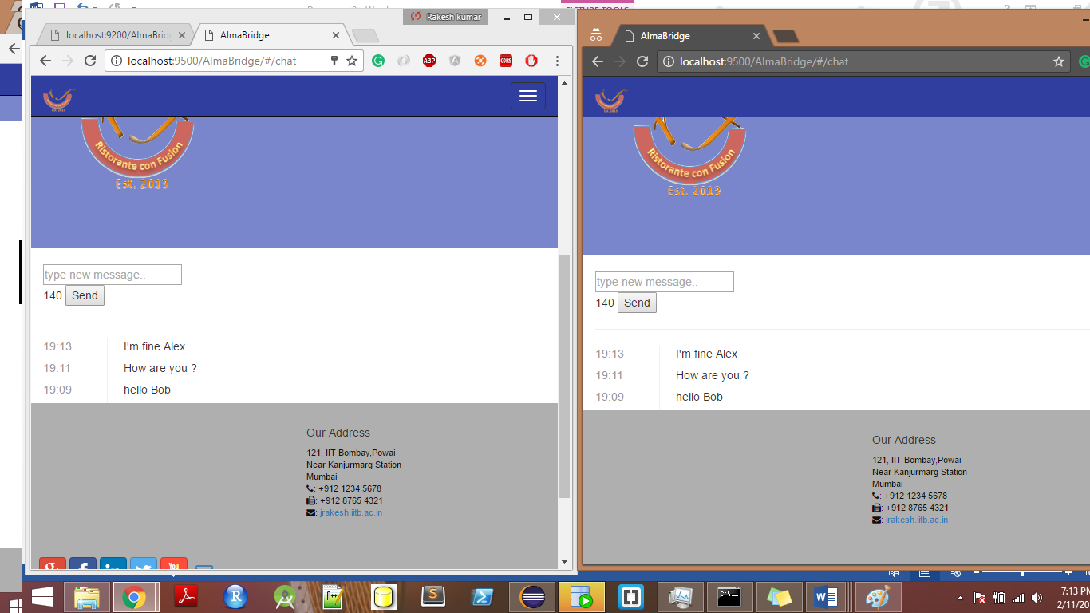

**Thank you.**